**Project Documentation**: Analysis of Food Delivery Preferences

**1. Project Title**

**"Food Delivery Insights: Analyzing Customer Preferences and Trends"**

**2. Objective**

The objective of this project is to analyze customer preferences and trends in the food delivery industry, focusing on frequently ordered items, demographic influences, and key patterns driving food delivery choices.

**3. Dataset Overview**

The dataset contains information on customer demographics, preferences, food categories, and ordering behavior. The following key columns were analyzed:

* **Age, Gender, Marital Status**
* **Occupation, Family Size**
* **Frequently Ordered Meal Category**
* **Rating, Order Value, Preference**

**4. Tools and Techniques Used**

* **Tool for Visualization**: Tableau
* **Data Cleaning and Preprocessing**: Python (Pandas)
* **Visualization Techniques**: Bar charts, pie charts, heatmaps

**5. Analysis and Insights**

**5.1 Most Frequently Ordered Items**

* **Finding**: Food delivery apps are the most commonly used medium for ordering meals, with **lunch** being the most preferred meal type.

**5.2 Category Analysis by Gender and Age**

* **Finding**:
  + Males aged **20-25** predominantly prefer **non-vegetarian lunch** through food delivery apps.
  + Gender and age play a significant role in meal preferences.

**5.3 Marital Status Insights**

* **Finding**: Single individuals are the primary users of food delivery services, showcasing their reliance on convenient meal options.

**5.4 Occupation Trends**

* **Finding**: The majority of orders are placed by **students**, highlighting their reliance on food delivery apps for meals.

**5.5 Rating and Ordering Trends**

* **Finding**: Food delivery apps with higher ratings receive a larger volume of orders, indicating that ratings significantly influence customer decisions.

**5.6 Family Preferences**

* **Finding**: Families tend to prefer **non-vegetarian meals**, making it the dominant choice for group orders.

**6. Visualizations in Tableau**

The project utilized the following visualizations to derive insights:

1. **Bar Chart**: Most frequently ordered items by food category.
2. **Pie Chart**: Distribution of marital status among users.
3. **Stacked Bar Chart**: Gender-wise preferences across age groups.
4. **Heatmap**: Correlation between ratings and order volume.
5. **Line Chart**: Family size and meal preferences.

7.Screenshot  
  
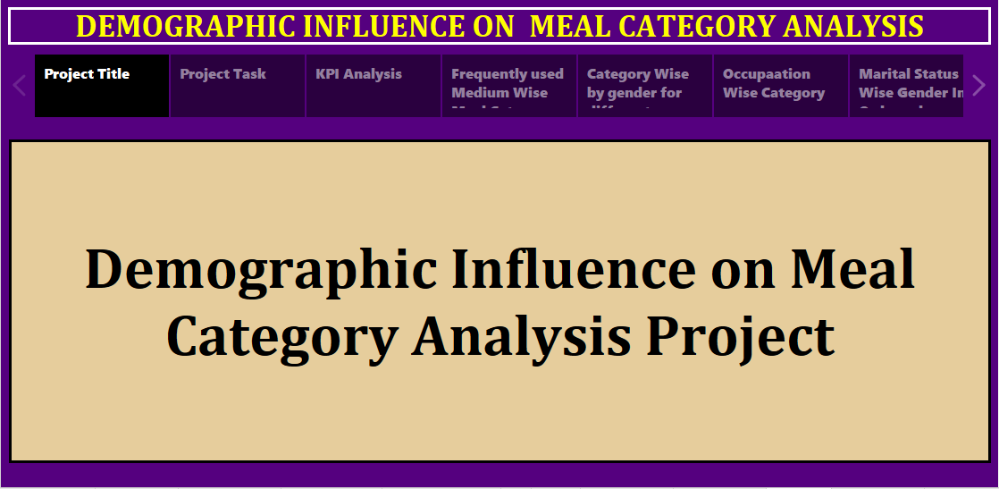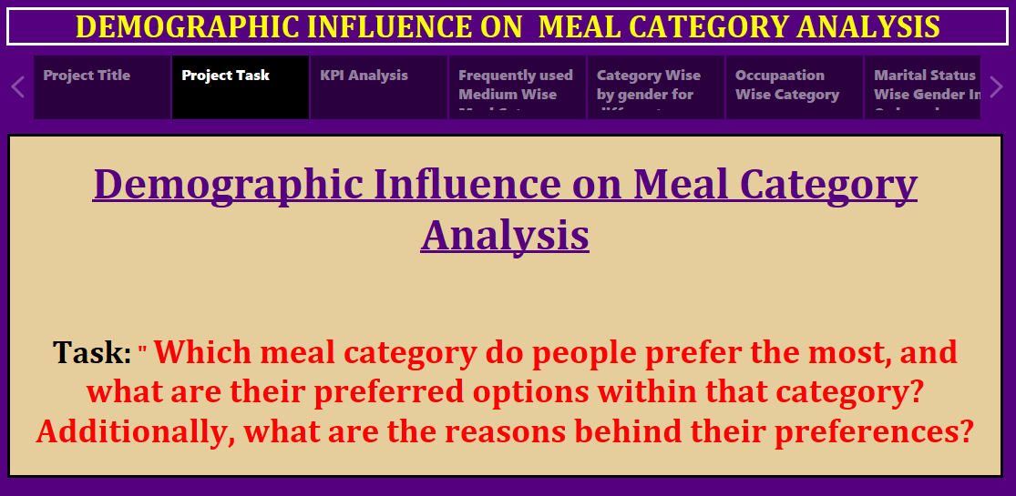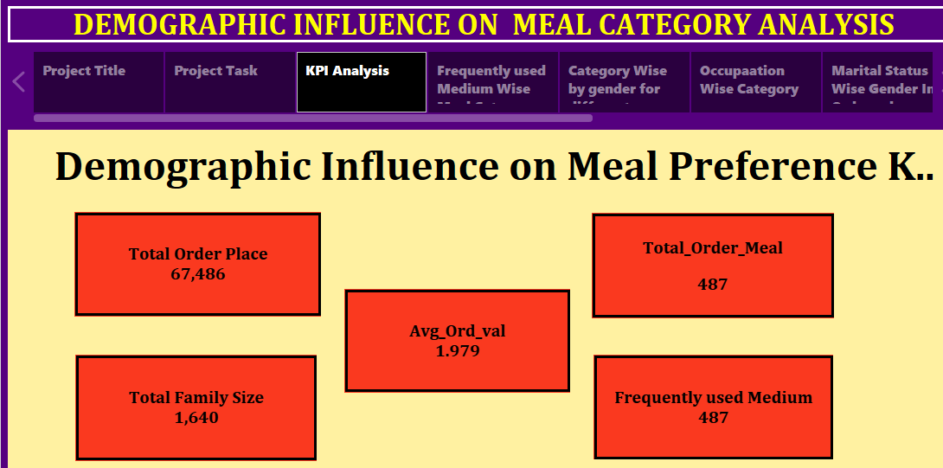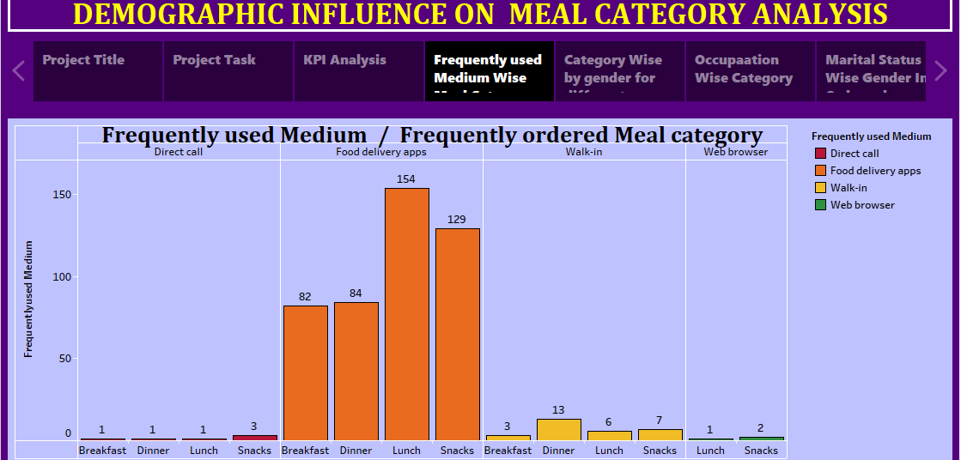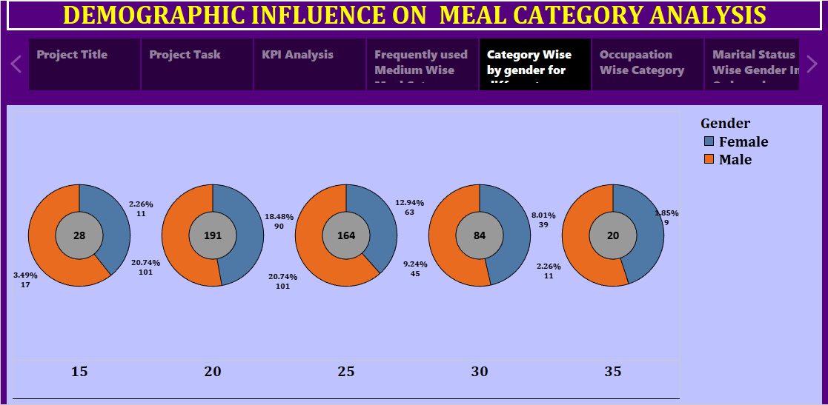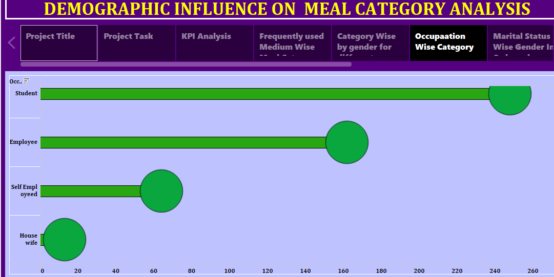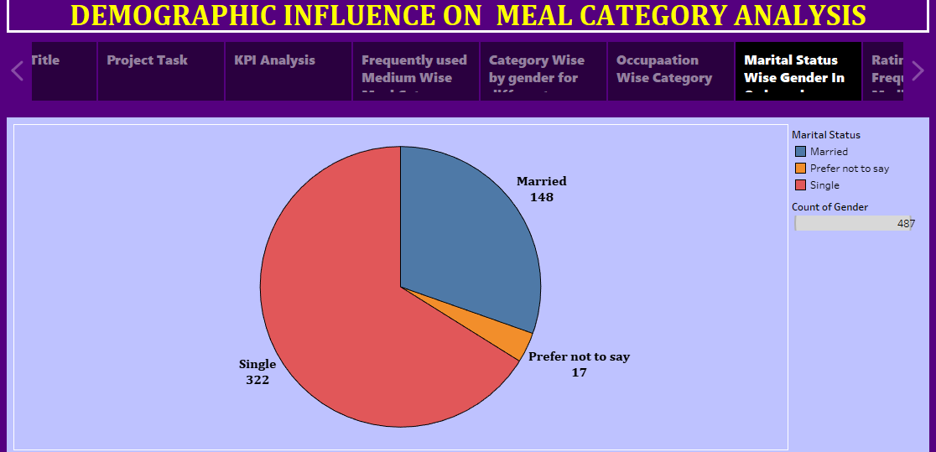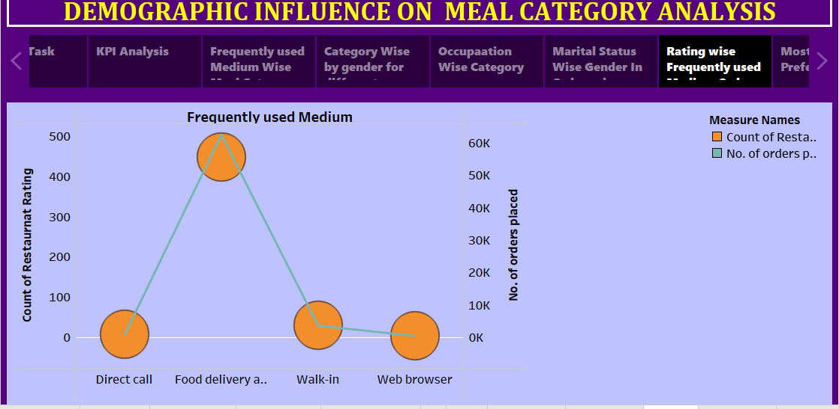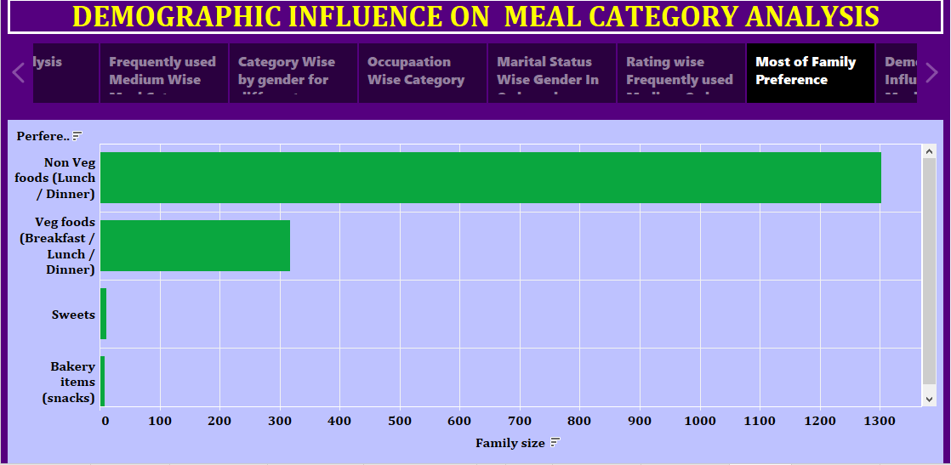

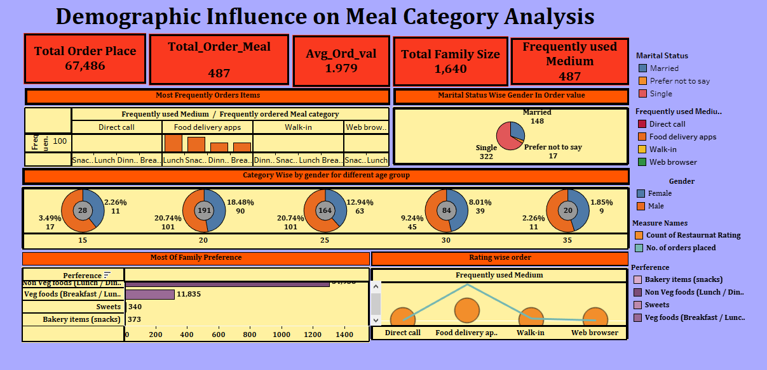

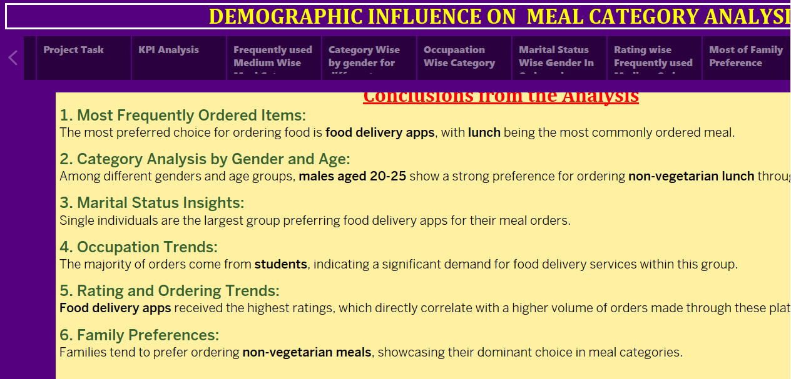

**8. Conclusion**

The analysis reveals key patterns in food delivery behavior:

1. Lunch is the most commonly ordered meal via food delivery apps.
2. Young males aged 20-25, particularly students, are the primary users of these services.
3. Ratings and convenience significantly influence ordering decisions.
4. Families prefer non-vegetarian meals, showcasing their dominant choice for group orders.

**9. Recommendations**

Based on the findings, the following recommendations can enhance customer engagement:

1. **Targeted Marketing**: Focus on campaigns for students and young adults aged 20-25.
2. **Family Deals**: Introduce family-centric non-vegetarian meal bundles.
3. **Rating Improvement**: Encourage users to provide feedback to improve app ratings.
4. **Lunch Offers**: Launch promotions specifically for lunch orders to capture high-demand segments.

**10 . Future Scope**

1. Analyze regional preferences in meal choices.
2. Study the impact of delivery time on customer satisfaction.
3. Incorporate more variables like weather or festival seasons to enhance insights.